Contents

1. PROBLEM DEFINITION 2

2. SUSTAINABILITY DEVELOPMENT GOALS 3

**a)** **SDG 11: Sustainable Cities and Communities** 3

**b)** **SDG 13: Climate Action** 4

**c)** **SDG 6: Clean Water and Sanitation** 4

**d)** **SDG 3: Good Health and Well-being** 4

**e)** **SDG 9: Industry, Innovation, and Infrastructure** 5

**f)** **SDG 14: Life Below Water** 5

3. GOVERNMENT ORGANISATIONS 5

4. DESIGN JUSTIFICATION – BIOMIMICRY 6

5. MATERIAL AND BODY DIMENSIONS 7

6. PRESSURE SENSOR 7

7. SONAR 7

**MAKE AVERAGE VALUE OF DISASTERS IN A YEAR**

**URIS Documentation Recourse Document**

# PROBLEM DEFINITION

EM_DAT: refer excel: public_emdat,

[List_of_topics](https://www.laspositascollege.edu/sitemap.xml)

**1. Global Perspective on Disasters**

From a total of 17,178 recorded disasters globally, 12,302 (approximately 71.6%) are classified as meteorological and hydrological events. These include disasters such as floods, storms, and mass movements that are primarily water-related. Specifically, 6,012 of these events are flood-related, comprising 66% of all water-based disasters.

In ppt:

From the total recorded disasters globally, approximately 71.6% are classified as meteorological and hydrological events. ~~These include disasters such as floods, storms, and mass movements that are primarily water-related~~. Specifically, 6,012 of these events are flood-related, comprising 66% of all water-based disasters.

**2. Asia's Vulnerability to Floods**

Asia is significantly impacted by disasters, with 6,876 recorded events in total. Out of these, 1,659 are flood-based, representing 24% of all disasters in the region. Since 2000, the number of disasters in Asia totals 3,957, with flood-related events accounting for 42% of them. This indicates a notable increase in the proportion of flood-related disasters in recent decades.  
  
In ppt:  
Asia is significantly impacted with 6,876 recorded events in total. Out of these, 1,659 are flood-based, representing 24% of all disasters in the region. Since 2000, the number of disasters in Asia totals 3,957, with flood-related events accounting for 42% of them.

**3. India: A Closer Look**

India has recorded a total of 782 disasters, with 327 being flood-based, representing 42% of the total. Since 2000, the number of flood-related disasters has increased to 198, making up 49% of all disasters in the country post-2000.

***Types of Floods in India:***

General Floods: 1,326

Riverline Floods: 2,024

Coastal Floods: 41

Flash Floods: 707

Glacial Lake Outburst Floods: 4

This results in a total of 4,102 flood events, highlighting the diversity and prevalence of different types of flooding.

**4. Human Impact in India Post-2000**

The human toll in India due to flood-based disasters after 2000 is staggering:

Deaths: 35,586

Injured: 7,620

Affected Population: 353,403,094

Homeless: 10,383,097

Total Affected: 363,793,811

Total Damage: $1,000,073,680

These figures demonstrate the devastating impact floods have had on India, with 27% of global flood-related deaths occurring in the country, despite India contributing only 5% to the global flood disaster count.

**5. Comparative Analysis Post-2000**

In India, post-2000, flood-based disasters have accounted for 49% of all disasters. When looking at the broader context of flood impact:

Deaths: 27% of the global total

Injured: 2%

Affected Population: 20%

Homeless: 52% (a significant proportion indicating severe displacement)

Total Affected: 20% of the global total

This data underscores the disproportionate human and economic impact of floods in India compared to other regions.

**Conclusion**

The analysis reveals that flood-based disasters are a major concern globally, particularly in Asia and India. The increasing frequency and severity of these events post-2000 highlight the need for enhanced disaster management strategies, especially in flood-prone regions like India. With significant percentages of global deaths, injuries, and displacements occurring in India, addressing the causes and effects of floods through better infrastructure, early warning systems, and climate adaptation measures is critical for reducing future risks and impacts.

**Recent Events:**

1. [2023 Chennai floods](https://en.wikipedia.org/wiki/2023_Chennai_floods), heaving flooding in [Chennai](https://en.wikipedia.org/wiki/Chennai) in December 2023 due to [Cyclone Michaung](https://en.wikipedia.org/wiki/Cyclone_Michaung).

* Formed 1 December 2023
* Rivers including Cooum and major lakes overflowed in Chennai causing further water logging in the low-lying areas along the banks.
* At least 17 people were killed, and more than 41,000 people were evacuated and temporarily relocated, including 32,158 in Tamil Nadu and 9,500 in Andhra Pradesh.

1. [2023 Thoothukkudi-Tirunelveli floods](https://en.wikipedia.org/w/index.php?title=2023_Thoothukkudi-Tirunelveli_floods&action=edit&redlink=1), heaving flooding in [Thoothukkudi](https://en.wikipedia.org/wiki/Thoothukkudi_district) and [Tirunelveli](https://en.wikipedia.org/wiki/Tirunelveli_district) districts in December 2023 due to heavy rainfall.
2. [2023 Himalayan floods](https://en.wikipedia.org/wiki/2023_Himalayan_floods) occurred after heavy rain caused flooding and landslides, killing at least 50 people

* Duration August 14, 2023
* 72 people were killed due to the floods.
* at least 700 flooded roads were closed in Himachal Pradesh district.

1. 2021 Uttarakhand flood, flood in Uttarakhand in February 2021 caused by an avalanche from Ronti peak

* Date 18 February 2021
* The disaster left over 200 killed or missing.
* As of May 2021, "83 bodies and 36 human body parts out of a total of 204 people missing have been recovered so far.

1. [2020 Hyderabad floods](https://en.wikipedia.org/wiki/2020_Hyderabad_floods), flash flood in [Hyderabad](https://en.wikipedia.org/wiki/Hyderabad) in October 2020 that caused 98 fatalities, a part of the [2020 North Indian Ocean cyclone season](https://en.wikipedia.org/wiki/2020_North_Indian_Ocean_cyclone_season)

* Formed October 11, 2020
* In the first hurricane, 2 people died in Vijayawada, and 50 people died on different parts of Telangana, including 19 in Hyderabad.[21] Additionally, twenty seven people died in Maharashtra, totally 91
* In second hurricane, over 80 people lost their lives and about 40,000 families were displaced.

1. 2024 Persian Gulf floods

* Duration 14 April - 17 April
* In Oman, at least 19 people were killed due to the floods.[15] This included 10 schoolchildren and their driver whose vehicle was washed away by flood waters
* 5 in UAE
* Remnants of the severe thunderstorm system that caused the 2024 Persian Gulf floods affected Pakistan and Afghanistan, killing 700 people.

1. Vetri Duraisamy - Sutlej river

* The search for Vetri Duraisamy after the Sutlej river incident lasted for 9 days
* The National Disaster Response Force (NDRF), along with other teams, conducted extensive search operations before his body was recovered

Here is the consolidated data with main points, including the number of deaths:

1. 2023 Chennai Floods: December 2023 floods from Cyclone Michaung; 17 killed, 41,000+ evacuated in Tamil Nadu and Andhra Pradesh.

2. 2023 Thoothukkudi-Tirunelveli Floods: Heavy December 2023 rainfall caused severe flooding in Thoothukkudi and Tirunelveli districts.

3. 2023 Himalayan Floods: August 2023 floods and landslides killed 72; 700 roads closed in Himachal Pradesh.

4. 2021 Uttarakhand Flood: February 2021 avalanche-induced flood left over 200 dead/missing; 83 bodies recovered by May.

5. 2020 Hyderabad Floods: October 2020 flash floods, part of cyclone season; 98 fatalities, 40,000 families displaced.

6. 2024 Persian Gulf Floods: April 2024 floods killed 19 in Oman, 5 in UAE, and 700 in Pakistan and Afghanistan.

7. Vetri Duraisamy - Sutlej River: NDRF search lasted 9 days before recovering Vetri Duraisamy’s body after river incident.

# SUSTAINABILITY DEVELOPMENT GOALS

[ADD IMAGE]

| **SDG** | **NAME** | **TARGETS** |
| --- | --- | --- |
| 11 | **Sustainable Cities and Communities** | 11.5 |
| 11.B |
| 13 | **Climate Action** | 13.1 |
| 13.2 |
| 6 | **Clean Water and Sanitation** | 6.3 |
| 6.6 |
| 3 | **Good Health and Well-being** | 3.6 |
| 3.9 |
| 9 | **Industry, Innovation, and Infrastructure** | 9.4 |
| 14 | **Life Below Water** | 14.1 |
| 14.2 |

1. **SDG 11: Sustainable Cities and Communities**

**Goal:** Make cities and human settlements inclusive, safe, resilient, and sustainable.

**Relevant Targets:**

* **11.5**: By 2030, significantly reduce the number of deaths and the number of people affected and substantially decrease the direct economic losses relative to global gross domestic product caused by disasters, including water-related disasters, with a focus on protecting the poor and people in vulnerable situations.
  + **Project Relevance:** The ROV will directly contribute to reducing casualties and economic losses during water-related disasters by improving rescue operations and infrastructure resilience.
* **11.B**: By 2020, substantially increase the number of cities and human settlements adopting and implementing integrated policies and plans towards inclusion, resource efficiency, mitigation, and adaptation to climate change, resilience to disasters, and develop and implement, in line with the Sendai Framework for Disaster Risk Reduction 2015-2030, holistic disaster risk management at all levels.
  + **Project Relevance:** The ROV supports disaster risk management by providing advanced capabilities for underwater inspections and rescue operations.

1. **SDG 13: Climate Action**

**Goal:** Take urgent action to combat climate change and its impacts.

**Relevant Targets:**

* **13.1**: Strengthen resilience and adaptive capacity to climate-related hazards and natural disasters in all countries.
  + **Project Relevance:** The ROV enhances adaptive capacity by enabling rapid response and rescue operations during climate-related disasters such as floods.
* **13.2**: Integrate climate change measures into national policies, strategies, and planning.
  + **Project Relevance:** The use of ROVs in disaster-prone areas can be part of broader climate adaptation strategies and disaster preparedness plans.

1. **SDG 6: Clean Water and Sanitation**

**Goal:** Ensure availability and sustainable management of water and sanitation for all.

**Relevant Targets:**

* **6.3**: By 2030, improve water quality by reducing pollution, eliminating dumping, and minimizing the release of hazardous chemicals and materials, halving the proportion of untreated wastewater, and substantially increasing recycling and safe reuse globally.
  + **Project Relevance:** The ROV can aid in underwater inspections, detecting sources of pollution, and assisting in clean-up operations, contributing to cleaner water bodies.
* **6.6**: By 2020, protect and restore water-related ecosystems, including mountains, forests, wetlands, rivers, aquifers, and lakes.
  + **Project Relevance:** The ROV can help in monitoring and restoring underwater ecosystems affected by pollution or natural disasters.

1. **SDG 3: Good Health and Well-being**

**Goal:** Ensure healthy lives and promote well-being for all at all ages.

**Relevant Targets:**

* **3.6**: By 2020, halve the number of global deaths and injuries from road traffic accidents.
  + **Project Relevance:** The ROV can reduce deaths and injuries caused by water-related accidents, providing timely intervention in rescue operations.
* **3.9**: By 2030, substantially reduce the number of deaths and illnesses from hazardous chemicals and air, water, and soil pollution and contamination.
  + **Project Relevance:** The ROV can assist in detecting underwater pollutants and contaminants that pose a risk to human health, contributing to overall well-being.

1. **SDG 9: Industry, Innovation, and Infrastructure**

**Goal:** Build resilient infrastructure, promote inclusive and sustainable industrialization, and foster innovation.

**Relevant Targets:**

* **9.4**: By 2030, upgrade infrastructure and retrofit industries to make them sustainable, with increased resource-use efficiency and greater adoption of clean and environmentally sound technologies and industrial processes, with all countries taking action in accordance with their respective capabilities.
  + **Project Relevance:** The ROV represents a technological innovation that enhances infrastructure resilience, especially in water-based environments prone to natural disasters.

1. **SDG 14: Life Below Water**

**Goal:** Conserve and sustainably use the oceans, seas, and marine resources for sustainable development.

**Relevant Targets:**

* **14.1**: By 2025, prevent and significantly reduce marine pollution of all kinds, in particular from land-based activities, including marine debris and nutrient pollution.
  + **Project Relevance:** The ROV can assist in detecting and mitigating marine pollution, including identifying and removing debris from water bodies.
* **14.2**: By 2020, sustainably manage and protect marine and coastal ecosystems to avoid significant adverse impacts, including by strengthening their resilience, and take action for their restoration to achieve healthy and productive oceans.
  + **Project Relevance:** The ROV can monitor and support the restoration of underwater ecosystems, contributing to the health of marine environments.

# GOVERNMENT ORGANISATIONS

[ADD IMAGE WITH TEAM]

[ADD IMAGE OF ORGANISATIONS]

| **Sl. No** | **METHOD** | **ORGANISATIONS** |
| --- | --- | --- |
| 1 | Rescue | National Disaster Response Force (NDRF) |
| Indian Navy |
| State Disaster Management Authorities (SDMAs) |
| National Institute of Disaster Management (NIDM) |
| 2 | Monitoring | National Institute of Oceanography (NIO) |
| Central Pollution Control Board (CPCB) |
| Geological Survey of India (GSI) |
| National Remote Sensing Centre (NRSC) |
| Ministry of Environment, Forest and Climate Change (MoEFCC) |
| 3 | Inspection and Maintenance | Inland Waterways Authority of India (IWAI) |
| National Hydroelectric Power Corporation (NHPC) |
| Central Water Commission (CWC) |

# DESIGN JUSTIFICATION – BIOMIMICRY

| **MARINE ANIMAL** | **ADVANTAGES** | **DISADVANTAGES** | **SUITABILITY FOR ROV DESIGN** |
| --- | --- | --- | --- |
| **Dolphin** | Streamlined body reduces drag | Complex to replicate mechanically | **Moderate:** Offers high speed and agility, but complexity and energy use make it less practical for ROV design. |
| High maneuverability | High energy consumption for fast swimming |
| Echolocation for advanced navigation |
| **Shark** | Efficient swimmer with tail propulsion | Lower maneuverability in tight spaces | **Moderate:** Excellent for endurance and speed, but lower agility and engineering challenges limit its application. |
| Endurance for long-distance swimming | Complex skin structure to replicate |
| Rough skin reduces drag |
| **Jellyfish** | Extremely energy-efficient | Slow speed | **Low:** Suitable for slow, energy-efficient movement, but lacks the speed and control needed for complex operations. |
| Simple design with pulsating movements | Limited control and precision |
| **Stingray** | Efficient and quiet movement with undulating fins | Structural complexity in engineering | **High:** Ideal for ROV design due to balance of speed, efficiency, maneuverability, and engineering feasibility. |
| Excellent maneuverability |
| Low drag |
| Versatile motion from gliding to quick turns |
| **Turtle/Tortoise** | Strong, protective shell | Moderate speed | **Moderate:** Offers stability and durability, but slower speed and high drag can be mitigated for certain ROV applications, making it a reasonable but less optimal choice. |
| Stable and steady movement | Limited maneuverability when compared to Stingray |
| Good for long-distance travel | High drag from shell shape |

# MATERIAL AND BODY DIMENSIONS

Dimensions – Add image and values [2D screen]

| **MATERIAL** | **COMPONENTS** |
| --- | --- |
| PETG | Endcaps |
| Propellors |
| Sensor Casing |
| LED Casing |
| Some components inside the Electronics Pipe |
| PLA | The Main Body |

# PRESSURE SENSOR

| **CONTENT** | **VALUE** |
| --- | --- |
| Manufacturer: | TE Connectivity |
| Pressure Type: | Absolute |
| Operating Pressure: | 0 bar to 30 bar |
| Accuracy: | 50 mbar |
| Interface Type: | I2C |
| Operating Supply Voltage: | 3 V |

# SONAR

[ADD IMAGE OF SONAR SENSORS AND OUTPUT]

Indigenously developed SONAR System only bound by the monetary restrictions

Sonar capable of detecting obstacles for 2 meters in a range of 180 degrees

Not using other sonar systems because of high cost

| **SONAR** | **PRICE** | **PROVIDER** |
| --- | --- | --- |
| Sonoptix ECHO Multibeam Imaging Sonar | $9,000.00 | BlueRobotics |
| Ping360 Scanning Imaging Sonar | $2,650.00 |
| Sonar 3D-15 | $ 27,900.00 | Waterlinked |
| JW Fishers Scanning Sonar Scan-650 | $9,014.00 | Metaldetector.com |
| MicronSonar | $15,000.00 | TriTech |
| Panoptix™ PS31 | $1,499.99 | Garmin |
| Panoptix™ PS70 | $4,799.99 |

# USBL

The USBL technique works with a transceiver mounted on a ship or surface vessel which sends out acoustic pulses and receives the echoes and a transponder attached to the underwater object which receives the acoustic pulse and sends back a response.

A topside unit (Microcontroller in this case), is used to control the pulses being sent and process the recived data.

The distance is calculated by measuring the distance between the pulses sent and the pulses received along with the speed of sound.

The angle/direction is calculated based on the arrangement of the hydrophones in the transceiver at the surface.

The pulses sent here are of 40 Hz frequency

[ADD IMAGE OF USBL WORKING]

# ELECTRONICS PIPE

The electronics are put in a acrylic pipe of dimension ODxIDxLen.

The Electronic Pipe is sealed on both ends with 3D Printed Endcaps waterproofed with Epoxy Resin. The wires sealed with resin within the endcaps to avoid the water to pass through the wires.

The electronics pipe consist of the following

| **Sl. No** | **COMPONENTS** |
| --- | --- |
| 1 | 3D printed parts |
| 2 | 6x 18650 batteries or a pre-made battery pack |
| 3 | ESC 4-in-1 |
| 4 | Single ESC |
| 5 | 50A fuse |
| 6 | 2x LED drivers, |
| 7 | Pixhawk flight controller |
| 8 | Raspberry Pi 4 |
| 9 | IRF-1404 n-channel MOSFET |

[INSERT FLOW DIAGRAM]

# WIRING

Wiring is done using silicone wires because it has more flexibility, durability and it is more resistant to water than normal wires with pvc casing.

# WATER PROOFING

Water proofing is done by different methods in different places

| Epoxy Resin |
| --- |
| Grease |
| Acrylite Adhesive |
| Hot Glue Gun |
| Soldering |
| Waterproof Solder Heat Shrink |

# BLUEOS

BlueOS is open-source, community-oriented software ecosystem that runs onboard the underwater vehicles and has a connection to the cloud

It provides unified access to tools and services to give a cohesive, welcoming user experience on ROVs and robotic vehicles.

It enables integration with a wide range of sensors inculing, GPS, Sonar, camera, depth sensors, pressure sensors etc.

As an open-source platform, BlueOS allows you to customize and extend the software to meet specific project requirements.

# ARDUSUB

The ArduSub project is a fully-featured open-source solution for remotely operated underwater vehicles (ROVs) and autonomous underwater vehicles (AUVs).

ArduSub has extensive capabilities out of the box including feedback stability control, depth and heading hold, and *autonomous navigation.*

* Feedback control and stability
* Depth hold
* Heading hold
* Camera Tilt
* Light Control

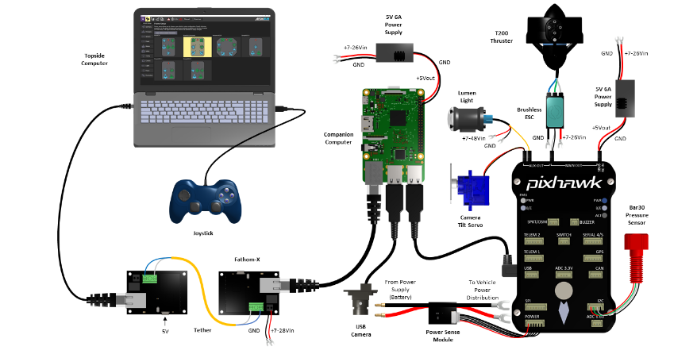

[source](https://www.ardusub.com/introduction/hardware-options/connection-diagrams.html)

# QGROUNDCONTROL

QGroundControl provides full flight control and vehicle setup for PX4 or ArduPilot powered vehicles. It provides easy and straightforward usage for beginners, while still delivering high end feature support for experienced users.

* Full setup/configuration of ArduPilot and PX4 Pro powered vehicles.
* Flight support for vehicles running PX4 and ArduPilot (or any other autopilot that communicates using the MAVLink protocol).
* Mission planning for autonomous flight.
* Flight map display showing vehicle position, flight track, waypoints and vehicle instruments.
* 3D viewer visualizing the 3D map of the environment (.osm file), the 3D model of the vehicle (only multi-rotors for the moment), and the mission 3D trajectory (including the waypoints).
* Video streaming with instrument display overlays.
* Support for managing multiple vehicles.
* QGC runs on Windows, OS X, Linux platforms, iOS and Android devices.

# TETHER

The Underwater robot is tethered using an ethernet cable. Ethernet net cable provides long distance transportation unlike a usb.

It has more buoyancy and durable.

Underwater Robot -- > Topside Computer

Other ways

Underwater Robot -- > wifi -- > Topside Computer

Wireless

Need less wavelength but this compromises the speed

Light based and sound based are costly

# BUOYANCY

The RoV has to have neutral buoyancy. To tackle the weight of the RoV, Buoyancy foam (PU?PS) is added inside the frame to achieve neutral buoyancy.

This enables the RoV to not drown as well as not float.

# END EFFECTORS

The RoV has a robotic arm with customizable end effectors.

This expands the use case of this robot to various domains.

# ASSEMBLY METHOD

The external components such as the motors/properllors, sensors, LED and servos are attached to the 3D printed body

The electronics pipe is placed inside the 3D printed body and the external components are connected to it through the wires coming out of the end caps.

# IMAGE PROCESSING

A image processing AL ML model is included in a web-based interface calibrated to identify humans underwater. Even if the controller in the ground station fails to identify, this image processing model helps/assists the user to identify, even in low light settings.

# MARKET VALUE

In addition, the rise in the demand for underwater drones for defense and security, exploration of deep water offshore oil and gas, and the demand for the product to modernize military forces by the government are the factors driving the market growth.

# COMPETITORS

ATLAS ELEKTRONIK GmbH

Blueye Robotics

Deep Ocean Engineering Inc.

Deep Trekker Inc.

General Dynamics Corporation Company Profile

iBubble

Kongsberg Gruppen ASA

Lockheed Martin Corporation

Oceaneering International Inc.

Saab Seaeye Limited

Teledyne Marine

The Boeing Company Company Profile

Other Key Players

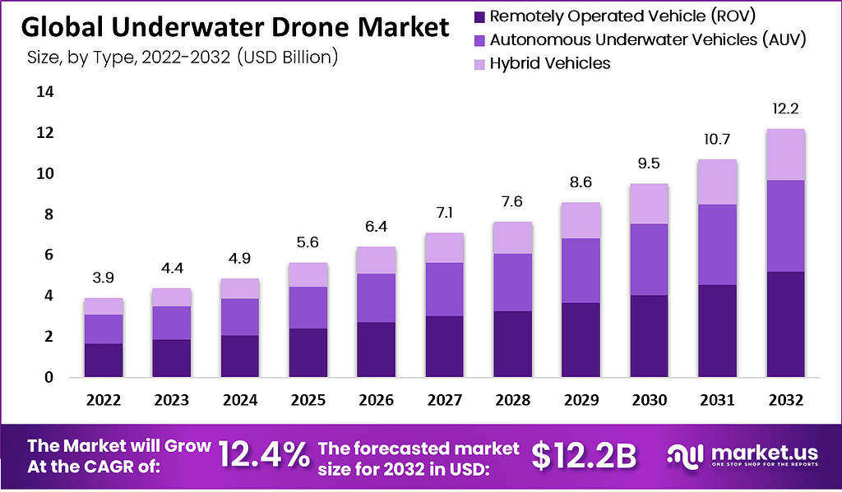

<https://market.us/report/underwater-drone-market/#overview>

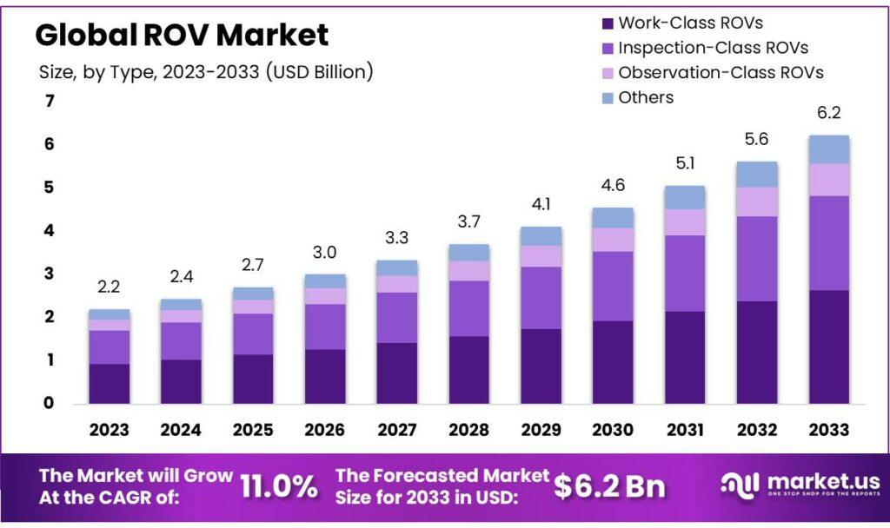

<https://market.us/report/rov-market/>

